Table 1: Selenium in Lake Macquarie fish compared with other Australian data

Species | Selenium concentration (μg/g wet weight)  (ranges, averages in brackets)
 | Background  (Maher et al., 1992) | Lake Macquarie  (Roberts, 1994), (Maher et al., 1997) | Lake Macquarie  (Wlodarczkyk and Beath, 1997)
Trumpeter whiting  (Sillago maculata) | 0.26-0.49  (0.37) | n/a | 0.81-1.93  (1.13)
Sea mullet  (Mulgil cephalus) | 0.1-0.3  (0.14) | 0.30-13  (2.0) | 0.33-3.47  (1.03)
Dusky flathead  (Platycephalus fuscus) | 0.10-0.33  (0.21) | n/a | 0.80-1.90  (1.35)
Yellowfin bream  (Acanthopagrus australis) | 0.10-0.60  (0.35)² | n/a | 0.45-3.44  (1.49)
Silverbiddy  (Gerres ovatus) | n/a | 0.46-12  (1.6) | n/a
Luderick  (Girella tricuspidata) | 0.21-0.32  (0.28) | n/a | 0.47-1.68  (0.97)
Blue swimmer crab | 0.23 | n/a | 0.33-3.47  (1.10)
average of data in each publication | 0.35 | 1.56 | 1.19

Figure 1: Lake Macquarie and the Vales Point area showing sampling sites
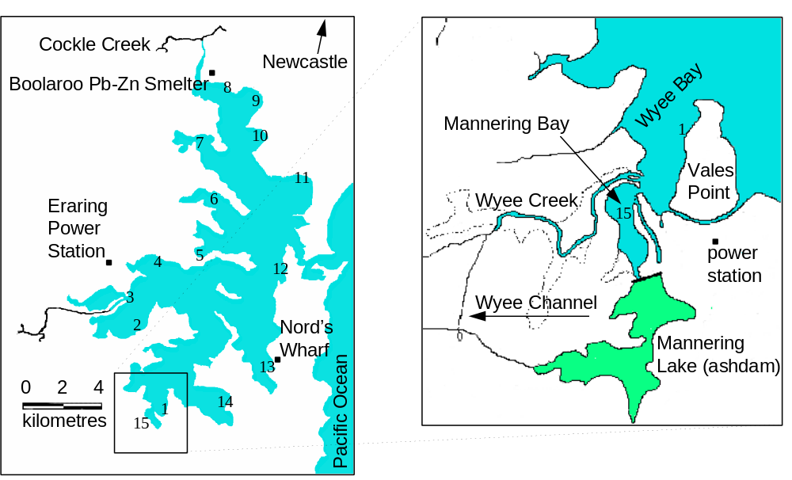

Table 2: Selenium in surficial Lake Macquarie sediments

Site | Location | Selenium concentration (μg/g dry weight)
 |  | Range | n | Mean ± S.D.
1 | Wyee Bay | 3.3 - 4.0 | 5 | 3.4±0.3
2 | Bonnells Bay | 1.5 - 3.0 | 3 | 2.2±0.6
3 | Dora Creek | 0.6 - 2.1 | 3 | 1.5±0.6
4 | Myuna Bay | 0.0 - 1.5 | 3 | 0.8±0.6
5 | Wangi Wangi Bay | 0.0 - 1.7 | 3 | 1.1±0.6
6 | Kilaben Bay | 0.0 - 1.0 | 3 | 0.4±0.8
7 | Fennell Bay | 1.4 - 1.9 | 3 | 1.7±0.2
8 | Cockle Bay | 2.0 - 3.3 | 3 | 2.5±0.6
9 | Warners Bay | 0.0 - 6.7 | 7 | 4.2±2.0
10 | Crowdace Bay | 0.1 - 1.7 | 3 | 0.8±0.7
11 | Belmont Bay | 0.4 - 1.0 | 3 | 0.7±0.2
12 | Swansea | 4.2 - 5.1 | 3 | 4.6±0.4
13 | Nord’s Wharf | 0.3 - 1.1 | 4 | 0.7±0.2
14 | Chain Valley Bay | 1.5 - 10 | 3 | 5.1±3.1
15 | Mannering Bay | 5.0-12 | 9 | 8.3±2.0
all sites |  | 0.0 - 12 | 58 | 2.7±2.2

Figure 2: Correlation between selenium concentrations in mullet and surficial sediments
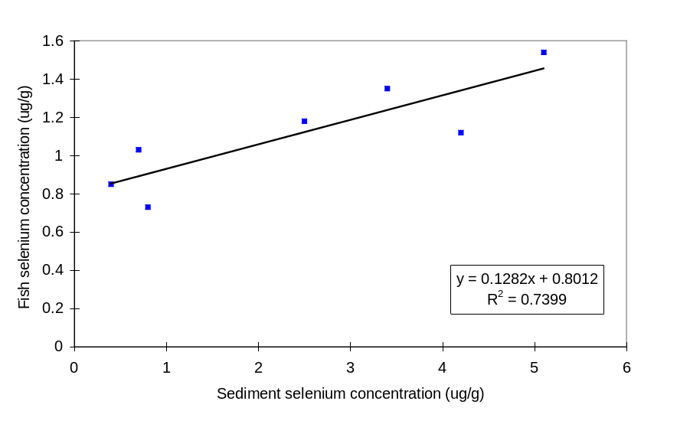
Table 3: Correlation of fish and sediment data
Fish | slope (b) | R² | d.o.f. | t
Whiting | 0.0483 | 0.1875 | 5 | 1.07
Mullet | 0.1281 | 0.7399 | 5 | 3.77*
Flathead | 0.1091 | 0.5622 | 6 | 2.78*
Bream | 0.1216 | 0.3980 | 6 | 1.99⁺
Luderick | 0.0480 | 0.3097 | 4 | 1.34
Crab (n=5) | -0.1026 | 0.0459 | 3 | 0.38
Crab (n=4) | 0.0665 | 0.4287 | 2 | 1.23
mean | 0.0987 | 0.6440 | 6 | 3.29*
*significant at the 0.05 level
+significant at the 0.1 level
Figure 3: -Total selenium concentrations in Nord’s Wharf sediments
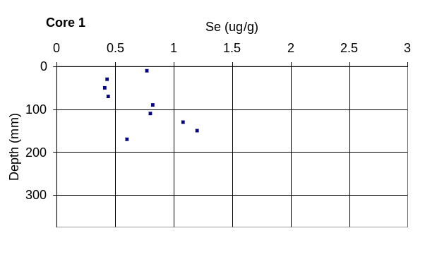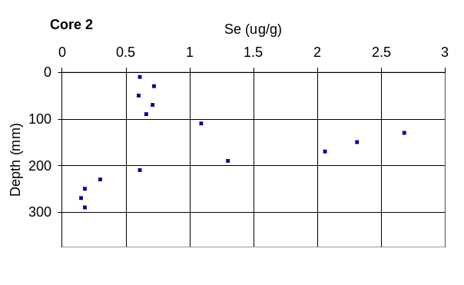
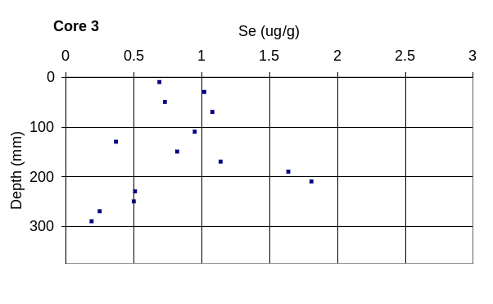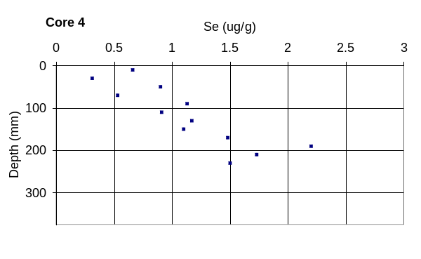

Figure 4: Total selenium concentrations in Mannering Bay sediments 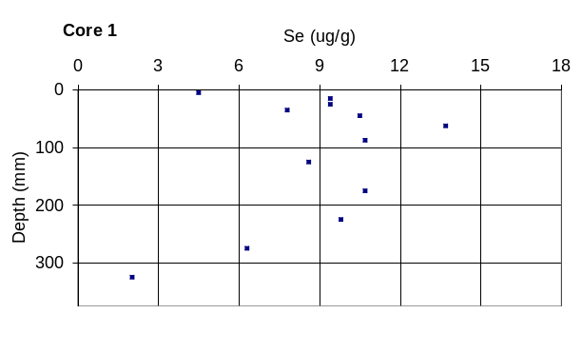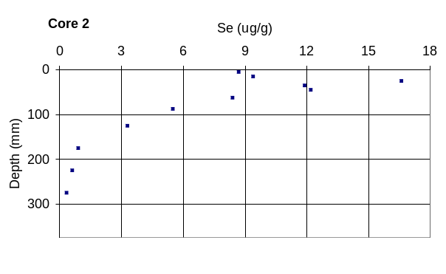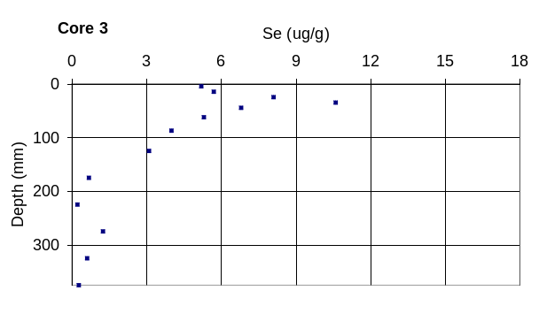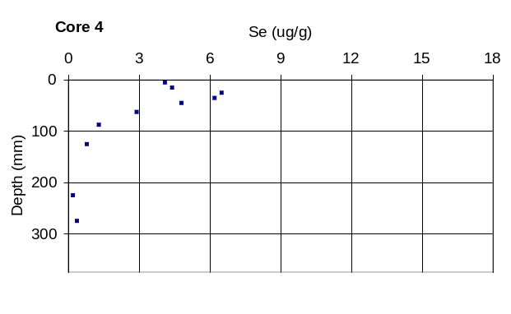

Figure 5: Mean selenium concentrations of sediment core profiles (error bars are standard deviations of samples)
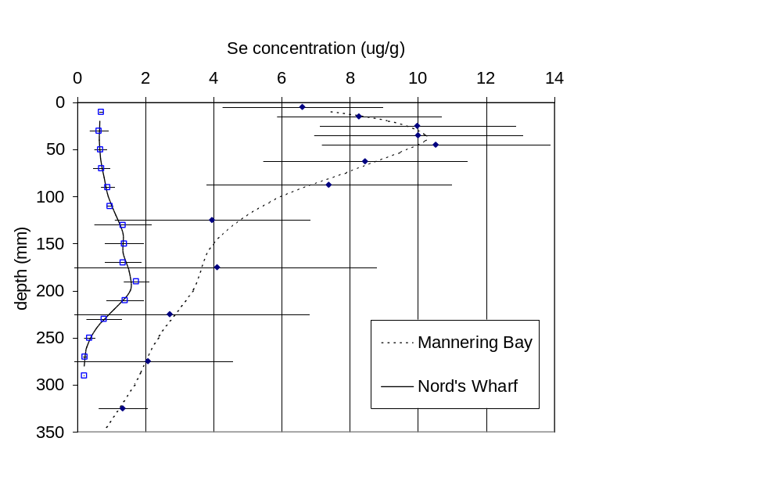

Fig. 6: Selenium in Mannering Bay sediment porewaters
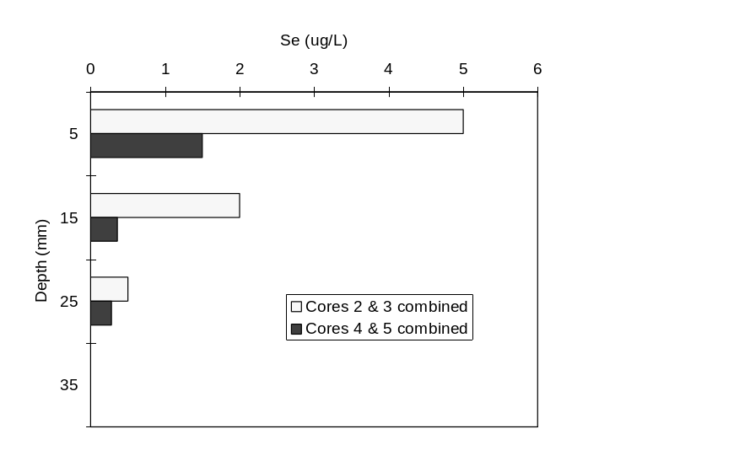
Table 4: Selenium concentrations in benthic fauna tissue

Organism | Location* | Selenium (μg/g dry weight)
 |  | n | Range | Mean ± S.D.
Mollusks:
Tellina deltoidalis | M | 16 | 12-52 | 32±19
Laternula tasmanica | M | 20 | 14-44 | 30±11
Trichamya hirsuta | NW | 15 | 2.2-7.5 | 3.7±0.3
Ostrea angasi | NW | 4 | 3.0-9.9 | 5.1±1.6
Tapes watlingi | NW | 6 | 3.3-8.5 | 4.6±0.8
Anadara trapezia | M | 2 | 7.3-20 | 14±6.4
Anadara trapezia | NW | 120 | 1.3-11 | 4.4±1.5
all mollusks | M | 38 | 7.3-52 | 32±12
all mollusks | NW | 145 | 1.3-11 | 4.4±1.1
Polychaetes | M | 11 | 16-70 | 41±23
Polychaetes | NW | 15 | 2.1-9.0 |  | 3.8±1.6
*M = Mannering Bay, NW = Nords Wharf
Figure 6: Bioaccumulation of selenium by benthic organisms

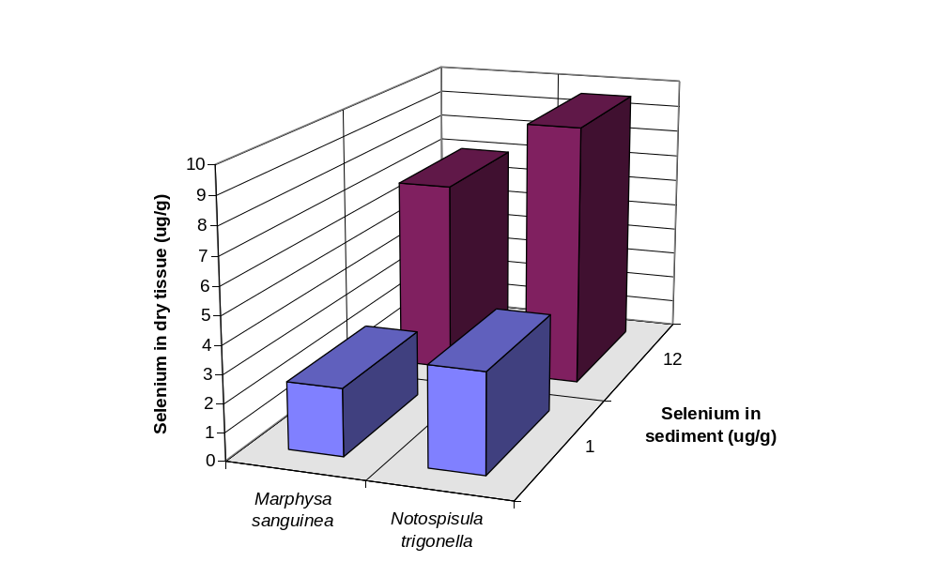

Data for Sillago ciliata
Maher WA, unpublished data
n = 1

